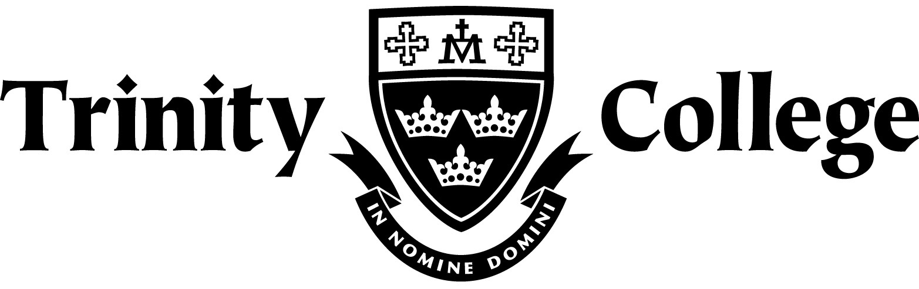

Chemistry
Organic Chemistry Test

DO NOT MARK THIS PAPER

Multiple choice 10 marks

1. Which of the following is not a pair of isomers?

A. ethyl benzene (C₆H₅-C₂H₅) and dimethyl benzene, C₆H₄(CH₃)₂
B. 1-propanol (CH₃CH₂CH₂OH) and 2-propanol (CH₃CHOHCH₃)
C. ethanol (C₂H₅OH) and dimethyl ether (CH₃OCH₃)
D. 2-butanone (CH₃COCH₂CH₃) and 1-butanol (CH₃CH₂CH₂CH₂OH)

2. Which reagents react to give ethyl benzoate (C₆H₅COOC₂H₅) and water? The structure of ethyl benzoate is given below.

3. In which of the following alternatives are the three compounds listed in order of increasing boiling point?

A. Pentane, butan-1-ol, propanoic acid
B. Propanoic acid, butan-1-ol, pentane
C. Propanoic acid, pentane, butan-1-ol
D. Butan-1-ol, propanoic acid, pentane

4. The raspberry-flavoured food additive, butyl methanoate, can be prepared from CH₃CH₂CH₂CH₂OH using

A. an addition reaction with HCOOH.
B. an addition reaction with CH₃COOH.
C. a condensation reaction with HCOOH.
D. a condensation reaction with CH₃COOH.

5. Which compound is least soluble in water?

A. CH₃CH₂CH₂F
B. CH₃CH₂CH₂NH₂
C. CH₃CH₂CH₂OH
D. CH₃CH₂CH₂COOH

6. How many different aldehydes have the formula C₅H₁₀O?

A. 2
B. 3
C. 4
D. 5

7. The boiling points of CH₃COCH₃, CH₃COC₂H₅, and CH₃COC₃H₇ are 56 °C, 80 °C, and
102 °C, respectively. This increase is best attributed to an increase in which of the following?

I dipole-dipole interactions
II dispersion forces
III hydrogen bonding

A. I only
B. II only
C. III only
D. II and III only

8. Which of the following statements would apply to compounds that belong to the same
homologous series?

I they have similar physical properties
II they have similar chemical properties
III they contain the same functional group
IV they have the same molecular formula but different structures

A. III only
B. IV only
C. II and III only
D. I, II, III and IV

9. Pure samples of which of the following exhibit hydrogen bonding?

I CH₃OH
II CH₃NO₂
III CH₃CN

A. I only
B. I and II only
C. II and III only
D. I, II, and III

10. The compound that is not an isomer of 2,2,4-trimethylpentane is

A. octane
B. 3-ethylhexane
C. 2,4-dimethylpentane
D. 2,4-dimethylhexane

1. Give the IUPAC name of the following structures:

(a)

(b)

(c)

(d)

(e)

(f)
CH₃CH₂CH₂COONa
[6 marks]

2. Give the full structural formula for the following organic chemicals:

(a) 1,2,3 - propantriol

(b) 6-amino-7-bromo-3-heptanone

(c) 2-ethylhexyl ethanoate

(d) cis-oct-3-ene

(e) trans-3-heptene

(f) 2,4-dimethylpentan-1-amine
[6 marks]

3. For each of the situations described below, determine whether or not a redox reaction would be expected and, if so:

(i) Write a balanced redox reaction showing the changes that take place;

(ii) Give a brief observation that would be expected to accompany the reaction.

(a) Acidified potassium permanganate solution is added to 2-methyl-3-pentanol.

(b) Limited acidified potassium dichromate is added to hexanol.
[8 marks]

4. DRAW and NAME the major organic PRODUCT or PRODUCTS in the following reactions assuming appropriate conditions. NB. No balancing is required.

(a) Ethanol and pentanoic acid with H₂SO₄ as a catalyst.
(b) Ethane and chlorine.

(c) Bromine and Benzene in the presence of UV light.

(d) Pentene and hydrogen chloride in the presence of a catalyst
[8 marks]

6. (a) Elementary analysis of a compound indicated that it contained only carbon, hydrogen, nitrogen and oxygen. A 1.279g sample was burned completely in oxygen such that all the carbon was converted to carbon dioxide and the hydrogen to water. This resulted in 1.600g of carbon dioxide and 0.770g of water. A separate 1.279g sample was shown by analysis to contain 0.1697g of nitrogen. Calculate the empirical formula of the compound.

(b) Given that the molecular mass of the compound was found to be 105g.mol⁻¹, determine the molecular formula.

(c) Given that the compound is a primary amine, reacts rapidly with sodium metal yielding an alkanoate and can be neutralized with NaOH, draw a possible structure.

[8 marks]

